Frontend
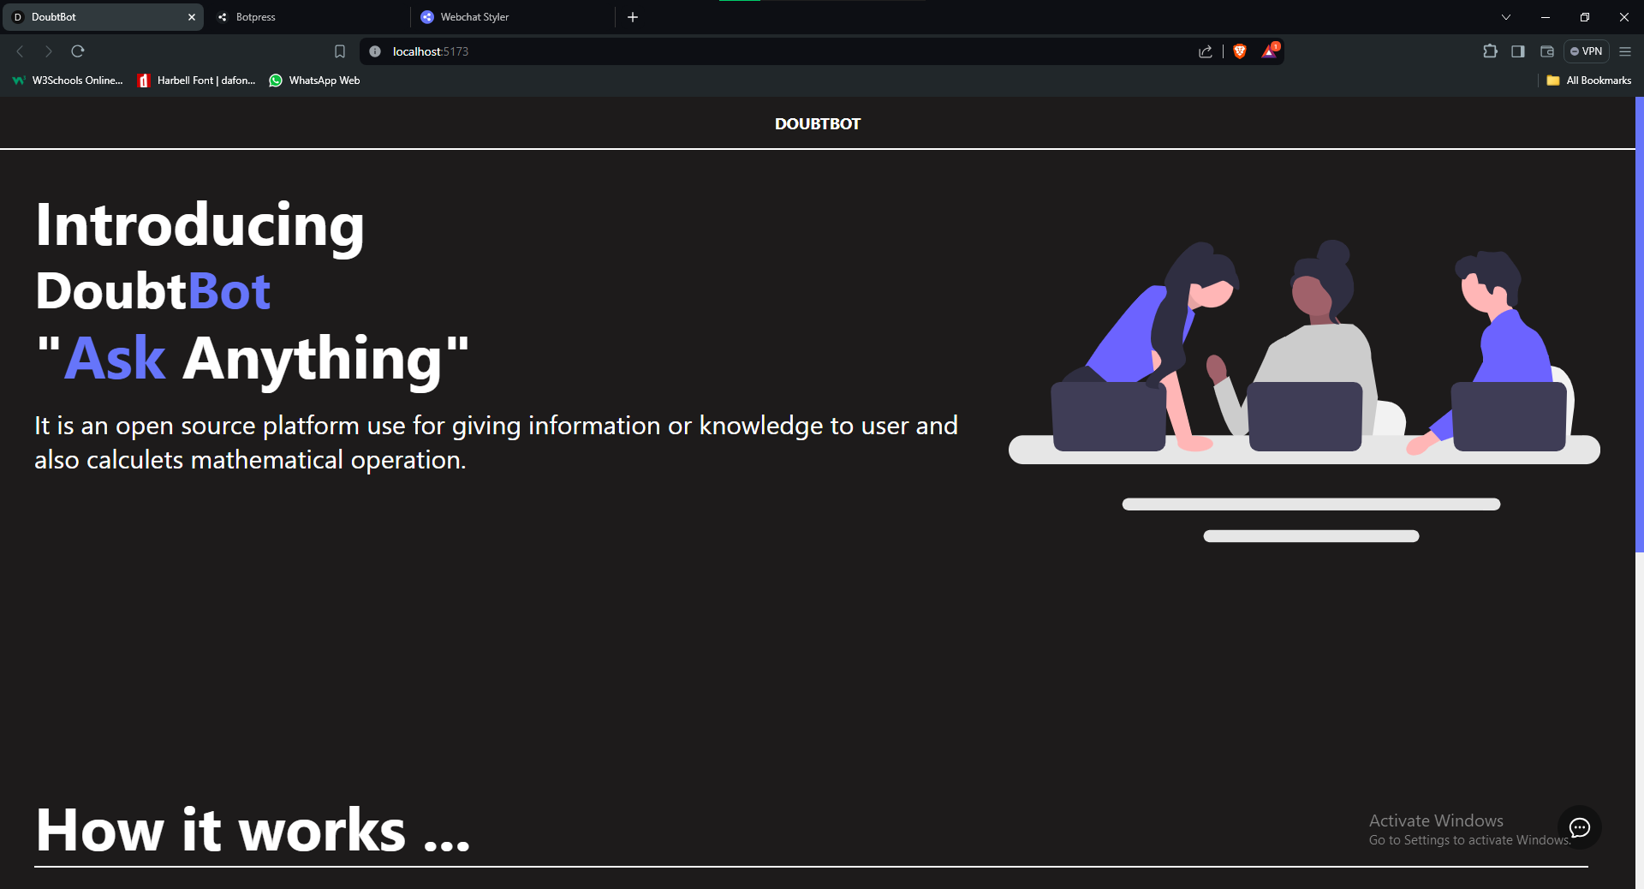
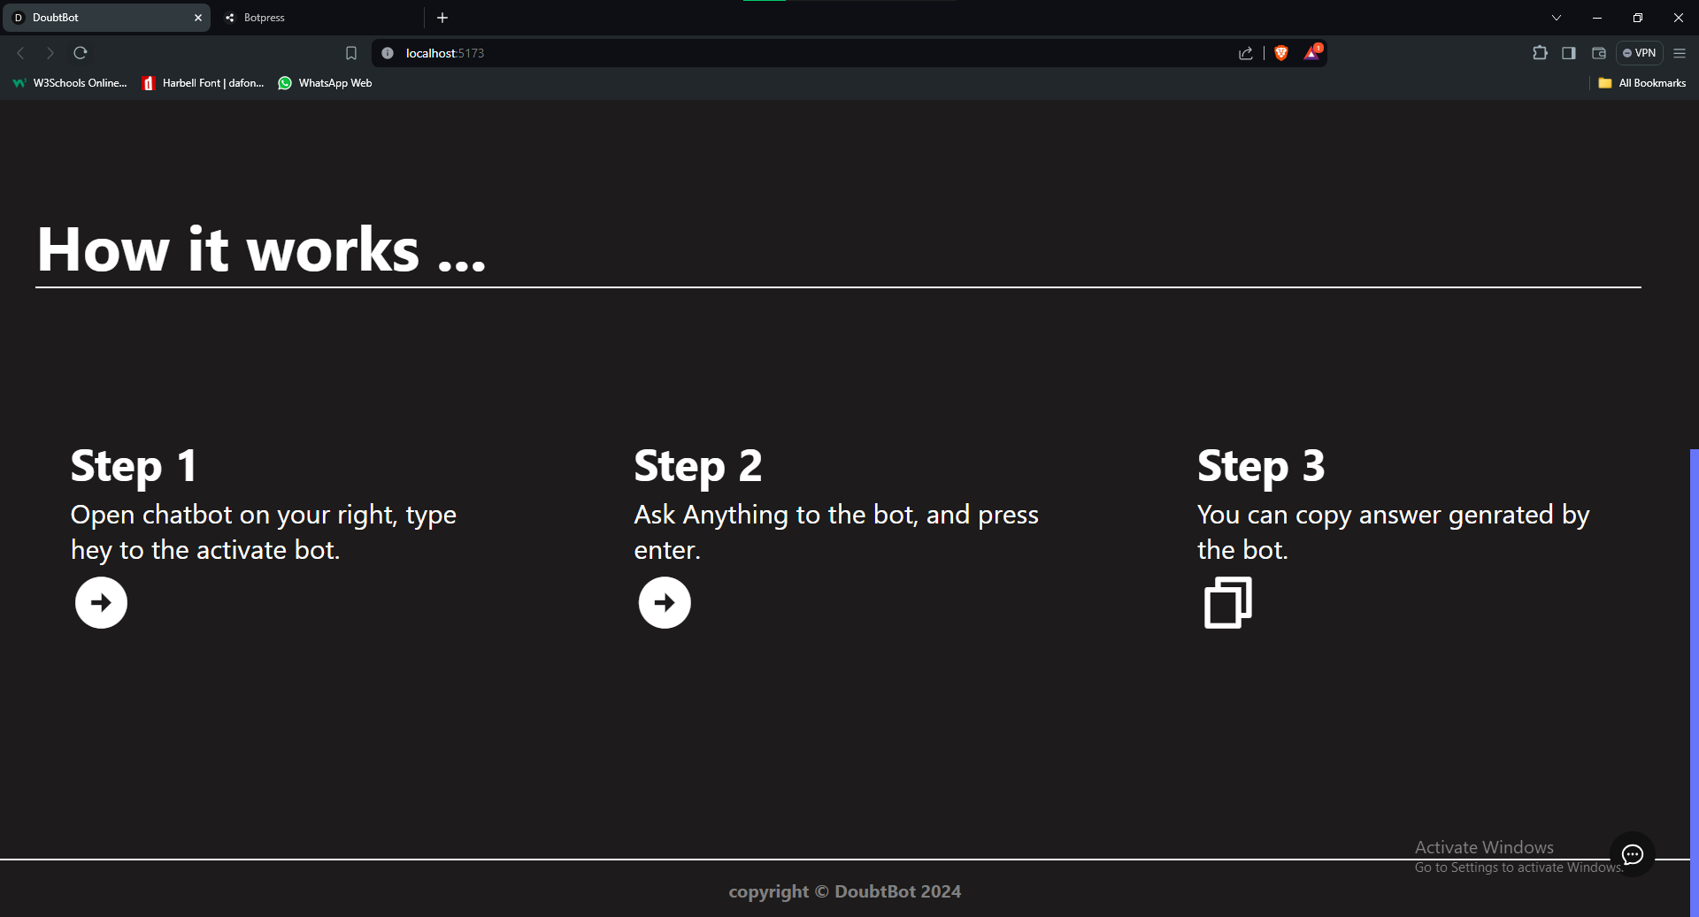

Html
<nav>
<a href="/"><h3>DOUBTBOT</h3></a>
</nav>
<div className="container">
<div className="page1">
<h2>Introducing</h2>
<h1>Doubt<span>Bot</span></h1>
<h3>"<span>Ask </span>Anything"</h3>
<p>It is an open source platform use for giving information or knowledge to user and also calculets mathematical operation.</p>
</div>
<div className="page2">
<svg ></svg>
</div>
</div>
<div className="work">
<h1>How it works ...</h1>
<div className="borderl"></div>
<div className="works">
<div className="works1">
<h2>Step 1</h2>
<p>Open chatbot on your right, type hey to the activate bot.</p>
<i class="ri-arrow-right-circle-fill"></i>
</div>
<div className="works2">
<h2>Step 2</h2>
<p>Ask Anything to the bot, and press enter.</p>
<i class="ri-arrow-right-circle-fill"></i>
</div>
<div className="works3">
<h2>Step 3</h2>
<p>You can copy answer genrated by the bot.</p>
<i class="ri-file-copy-line"></i>
</div>
</div>
</div>
<footer>
<h4>copyright © DoubtBot 2024</h4>
</footer>

App css
body{
background-color: #1d1b1b;
}

nav{
width: 100%;
height: 60px;
background-color: #1d1b1b;
border-bottom: 2px solid white;
color: white;
display: flex;
align-items: center;
justify-content: center;
font-size: 16px;
}

nav a{
text-decoration: none;
color: white;
}

.container{
width: 100%;
height: 80vh;
background-color: #1d1b1b;
color: #fff;
display: flex;
}

@media(max-width: 375px){
.container{
width: 100%;
height: 100%;
background-color: #1d1b1b;
color: #fff;
display: flex;
}
}

.container .page1{
padding: 40px;
height: 100%;
width: 60%;
}

.page1 h2{
font-size: 70px;
line-height: 1.2;
}

.page1 h3{
font-size: 70px;
line-height: 1.2;
}

.page1 h3 span{
font-size: 70px;
color: #6675fa;
}

.page1 h1{
font-size: 60px;
line-height: 1.2;
}
.page1 h1 span{
font-size: 60px;

color: #6675fa;
}

.page1 p {
font-size: 30px;
padding-top: 20px;
}

.container .page2{
height: 100%;
width: 40%;
}

svg{
width: 36vw;
padding-top: 60px;
}
@media(max-width: 790px) {
.container .page2{
display: none;
}

}
footer{
display: flex;
border-top: 2px solid white;
background-color: #1d1b1b;
justify-content: center;
text-align: center;
color: white;

width: 100%;
height: 5%;
font-size: 20px;
}
footer h4{
padding-top: 20px;
padding-bottom: 20px;
color: grey;
}

.borderl{
border-top: 2px solid white;
height: 10%;
width: 95%;
margin-left: 40px;
}

.work{
width: 100%;
height: 80vh;
background-color: #1d1b1b;
color: #fff;
}

.work h1{
font-size: 70px;
padding-left: 40px;
}
.works{
display: flex;
justify-content: space-around;
width: 100%;
height: 70%;
background-color: #1d1b1b;
padding-top: 90px;
}

.works1{

width: 25%;
height: 50%;
}

.works2{

width: 25%;
height: 50%;
}

.works3{

width: 25%;
height: 50%;
}

.works h2{
font-size: 50px;
margin-bottom: 3px;
}

.works p{
font-size: 30px;
margin-bottom: 3px;
}

.works i{
font-size: 70px;
}

Index css
*{
margin: 0;
padding: 0;
box-sizing: none;
font-family: system-ui, -apple-system, BlinkMacSystemFont, 'Segoe UI', Roboto, Oxygen, Ubuntu, Cantarell, 'Open Sans', 'Helvetica Neue', sans-serif;
}
body{
height: 100%;
width: 100%;
background-color: #1d1b1b;
}
::-webkit-scrollbar {
width: 10px;
}
::-webkit-scrollbar-track {
background: #1d1b1b;
}
::-webkit-scrollbar-thumb {
background: #6675fa;
}

